Friends of Addiction Studies

Committee Members

Mr. Analdo Bailey - CEO – Eastern Caribbean Institute of Banking and Financial Institutes (ECIB)

Mr. Ian Estwick - Barbados

Ms. Sonia Johnson - Business Development Officer, University of the West Indies, Cave Hill Campus, Barbados

Mr. Ishmael Morris - Retired, Deputy Director, Barbados National Council of Substance Abuse

Open Campus Students Receive Sponsorship for Substance Abuse On-Line Programme for the Academic Year 2008-2009

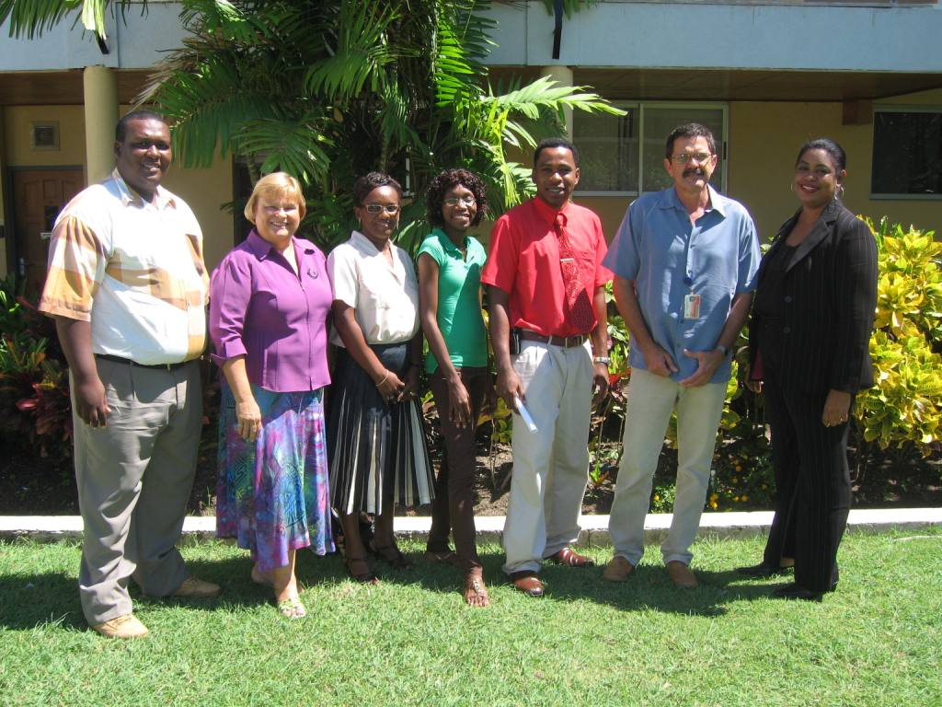

Students in the online Certificate in Substance Abuse Treatment and Prevention programme pose with sponsors from the Peter Moore's Foundation.

From left to right: Mr. Antonio Taylor, Programme Assistant, Certificate in Substance Abuse Treatment and Prevention; Ms. Karen Ring, Academic Committee Member and Lecturer, Faculty of Social Sciences, UWI Cave Hill Campus; Ms. Julia Edey, Recipient; Ms. Shamira Shorey, Recipient; Mr. Adrian Gooding, Recipient; Prof. Sean Carrington, Chairman, Peter Moore‟s Foundation and Dean, Faculty of Pure and Applied Sciences, UWI Cave Hill Campus; and Ms. Sonia Johnson, Friends of Addiction Studies Committee Member and Business Development Officer, UWI Cave Hill Campus.
Three Barbadian UWI Open Campus students – Julia Edey, Shamira Shorey and Adrian Gooding - are to benefit from sponsorship from the Peter Moores Barbados Trust to complete the online Certificate in Substance Abuse Prevention and Treatment for the academic year 2008-2009. The funding is the result of efforts by the Friends of Addiction Studies Committee.

The online Certificate in Substance Abuse Prevention and Treatment is a regional, UWI-based on-line continuing education programme in drug demand reduction, which will upgrade the professional qualifications of individuals engaged in national, regional and international efforts to prevent substance abuse in the Caribbean region and beyond. The programme seeks to enhance the regional response to the challenges associated with substance abuse through training and the development of a lasting network of professionals in this field, thereby improving the environment and the quality of care and service for their communities.

