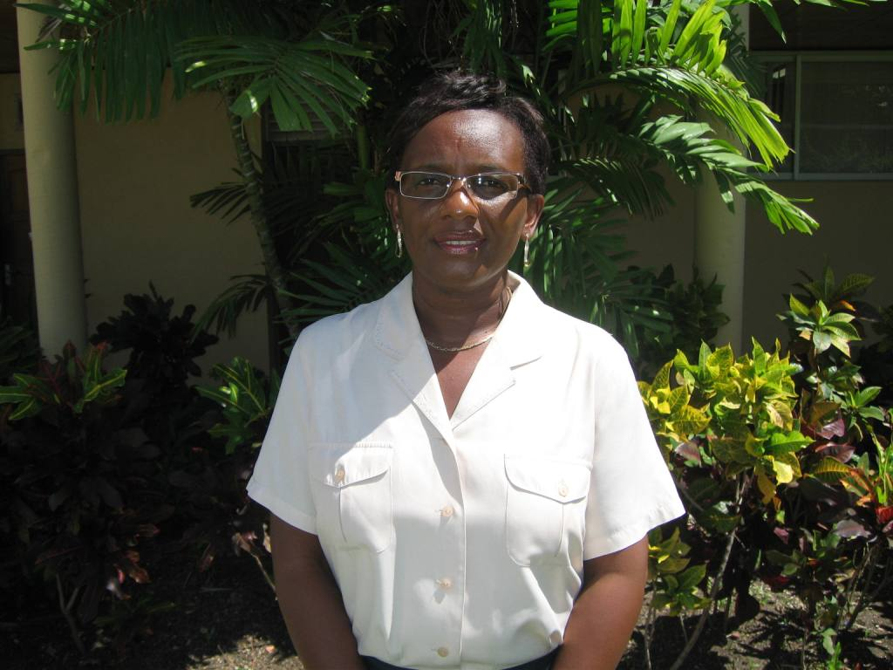
Julia C. Edey
Peter Moore’s Foundation Sponsorship Recipient

I have been employed in the field of education in Barbados for a total of 28 years. The vast majority of these years were spent at the St. George Secondary School, as a teacher of Home Economics. I am currently seconded to the post of Guidance Counsellor at the Parkinson Memorial School.

I received my primary education at the Workman’s Primary School, in St. George and secondary level education at the Ursaline Convent and St. George Secondary School. My tertiary level qualifications include a Bachelor of Arts (Honours) Degree in History as well as the Certificate in Educational Management and Administration from the Cave Hill Campus of the University of the West Indies, the Erdiston Teachers’ Training Certificate, and the Certificate in Guidance and Counselling from the School of Continuing Studies, University of the West Indies, Barbados.

My special interest is working with disadvantaged students helping them to improve their life experiences. I am a sewing enthusiast especially in dressmaking and household decorations. Reading, gardening and listening to music are my other hobbies.

My philosophy of life is quite simple - to make each day more interesting and productive than the day before. I am married and the mother of an eighteen year old son.

