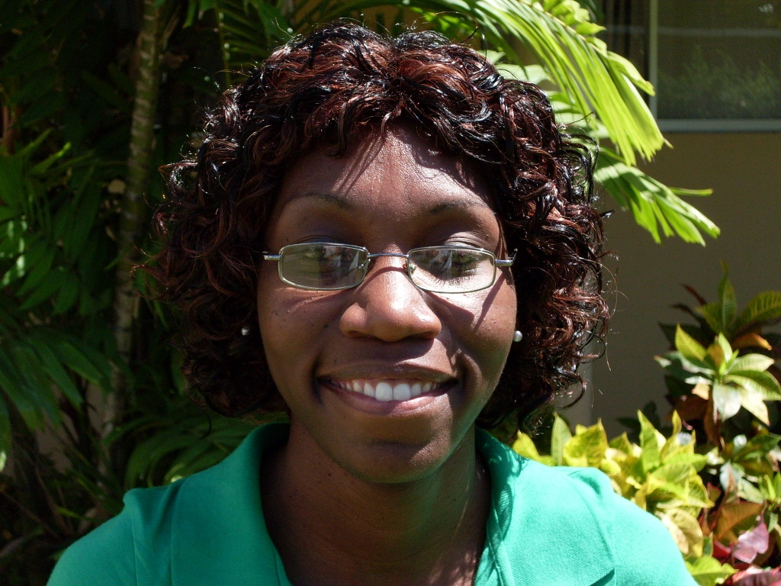

Ms. Shamira Shorey

Peter Moore’s Foundation Sponsorship Recipient

“What you do for yourself dies with you. What you do for others and the world lives forever and is immortal.”

Growing up in my neighbourhood, I have always been troubled by the vast amount of people engaged in substance abuse. In recent times, these numbers have not only increased, but the ages of the users have decreased tremendously. In my opinion, the use and abuse of drugs and alcohol in our island are being assimilated into the minds of our young people as the social norm and ultimately an acceptable way of life. The most hurtful thing about this dire circumstance is that most of these young people are not aware of the detrimental effects of their activities. Furthermore, there are persons who promote the misconception that illegal drugs are actually good for one’s health.

On seeing the advertisement for the course entitled Substance Abuse Prevention and Treatment in the Nation newspaper, my mind immediately raced with possibilities. However, the main concept was that this course would be used as an avenue not only to gain knowledge in the field, but to equip me with the tools necessary to adequately educate others. Realistically, I cannot change the entire world but if I can help small pockets of people in my community, hopefully this will cause a ‘chain reaction’ and we will begin to see positive behavioral change and attitudes as a result.

At present, I am an active member of the HIV/AIDS Hotline and a peer educator in the same area. I have been volunteering my services for approximately 3 years. Altogether, I am enthusiastic about this course (whether I make a career in the field, or solely volunteer my services) the fact remains that the knowledge gained will be used for the betterment of my community.

