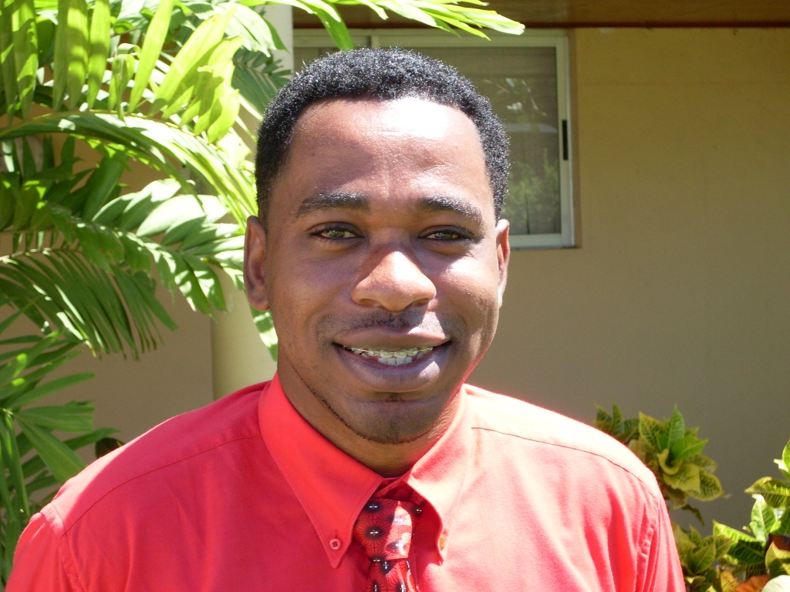

Mr. Adrian Gooding

Peter Moore’s Foundation Sponsorship Recipient

I have lived my entire childhood and most of my adulthood in the community of Brittons Hill, St. Michael. During this period, I have been witness to the various transformations which that microcosm of society has gone through with regard to social transformation. I have been exposed to issues of social inequity, crime and illicit substance use. A significant number of childhood friends are mired in substance use as a way of life and some have suffered because of related consequences; either through incarceration or other bio-psychosocial challenges.

I can point to my socialisation as the motivation to work in the Social Sciences. I am a Queens College Alumnus and I also point to my experiences there as a motivating factor in my career choice.

I initially pursued and achieved an Associate Degree in Computer Science from the BCC after being stimulated by electronic engineering and visualising myself as becoming very wealthy through that pursuit, but alas, there lacked a true passion for the field I then pursued what I felt would be a people-focused career and graduated from the University of the West Indies with a Bachelor of Science in Social Work. It was during the undergraduate program that I was exposed to substance abuse management and rehabilitation at Verdun House.

Since graduating from the UWI, I was reassignment from the Welfare Department (where I had worked until August 2007), to the HIV Management Program under what is now the Ministry of Health, National Insurance and Social Security. I am one of the nine Counsellors within the Ministry’s program and our responsibilities include Voluntary Counselling and Testing (VCT) and Social Work with the PLHIV population.

Because of my exposure at Verdun (and possibly throughout my lifetime) I am the counsellor assigned to comorbid HIV and substance abuse. To this end, I have attended and completed the basic program at CARIAD 34 which was hosted in Tobago in May 2008. I have since endeavored to “get down to business” and develop some meaningful intervention strategies for my comorbid clients in partnership with other professionals in the program.
My admission to the Certificate in Substance Abuse Treatment and Prevention is nothing short of a true blessing, since I don’t believe that it’s coincidence. I truly look forward to the interactions and the direction that will be included. Moreover, I look forward to what seems an awesome challenge vis-à-vis the amount of information/coursework that I have to read and understand.

